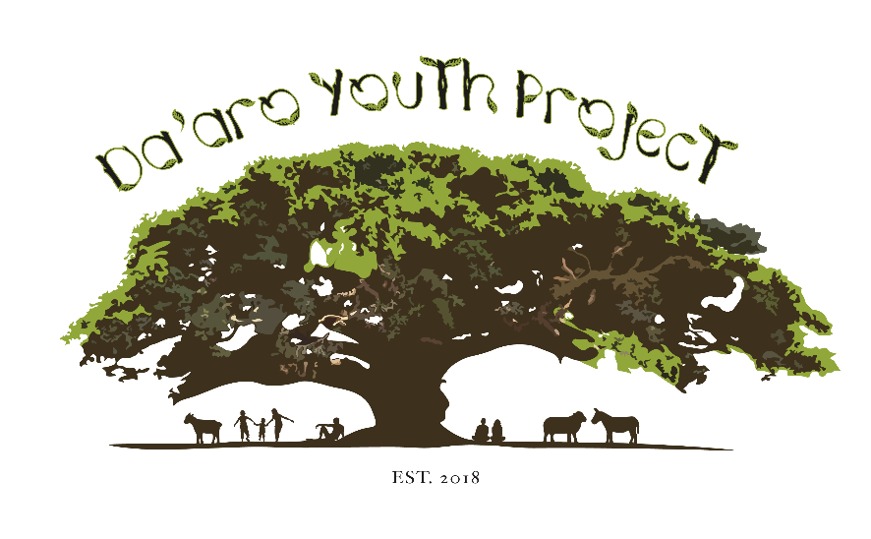

# **Job Description**

Job Title: Office Administrator

Reporting to: Youth Service Manager

Hours: Full Time

Status: 1 year contract (with extension subject to funding)

Salary: £28,000

Holiday Entitlement: 27 days per annum plus bank holidays

Location: Main office: Streatham Hill with some working from home. Outreach service / accompaniment of young people is also delivered in settings appropriate to client groups across London.

**Purpose of Role:**

To provide essential administrative and operational support to the charity’s programs for unaccompanied asylum seekers and refugees. This role will support the DYP Director and Service manager in daily administration work. The post holder will assist in coordinating logistics, managing records, and supporting different departments in the team to ensure that young people receive holistic support. The role will work closely with the DYP Director and Youth Service Manager to do this. This role also involves building relationships with local partners and stakeholders to enhance community connections and strengthen our network of support for young people. Additionally, the post holder will help manage and enhance the organization’s social media presence to raise awareness and engage the community.

The working hours for this role will be 9-5pm with a balance of remote working and office work in Streatham Hill, with a desired flexibility to cover youth clubs and activities where necessary.

**Duties:**

1. Managing daily office operations, including scheduling meetings, maintaining records, and handling correspondence.
2. Assist with the preparation and organization of documents for meetings and events.
3. Maintain and update databases and files related to program participants and activities.
4. Support financial tracking and reporting, including budgeting for events and managing petty cash.
5. Assist in preparing reports for funders and stakeholders.
6. To build effective partnerships with referral partners including local authorities and other stakeholders.
7. To maintain a high level of expertise in the support of the young people we work with by maintaining knowledge of the context in which we are working and the support available.
8. To ensure that work is monitored, evaluated and quality-assured to meet internal and external requirements. Work closely with the team to develop and implement operational processes that enhance efficiency.
9. To support DYP management and colleagues by providing information and reports as required.
10. To ensure that all activities are suitably risk assessed and adequately and safely supervised in accordance with our Health and Safety policy.
11. To maintain confidentiality and clear boundaries in all aspects of the role.
12. To maintain compliance with policies and procedures of DYP in relation to child and vulnerable adult protection, diversity and equality.
13. To attend supervision sessions and appraisals with the line manager, contribute to team meetings and collaborate positively with the DYP team.
14. To undertake training and self-development in order to develop skills and ensure an accurate knowledge and understanding of the issues facing, and policy affecting refugee, asylum seeking and recently arrived young people.
15. To abide by health and safety guidelines and share responsibility for your own safety and that of colleagues.
16. To undertake such other work appropriate to the post as may be assigned by the Youth Service Manager.
17. To uphold the Aims and Principles of DYP.

***About Da’aro Youth Project***

**We are a community-led organisation supporting young refugees from the Horn of Africa.**

Da'aro Youth Project was established in 2018 by members of the Eritrean community in London in response to the deaths of a number of teenage Eritreans by suicide. Eritreans were the largest nationality group of unaccompanied minors to arrive in the UK in 2017 and 2018. Asylum-seeking children and young adults arrive here after traumatic journeys through the Sahara Desert, Libya, the Mediterranean Sea and after crossing borders in Europe, such as in Calais. Once here, young people often struggle to adapt to new lives separated from their families, and find that navigating the complex asylum and social care systems can be stressful and traumatic.

We aim to promote the wellbeing of these migrant young people living in the UK, through direct support, through building bridges in the Eritrean community and through advocating for changes to unfair and discriminatory systems which undermine their wellbeing. We believe that building sustainable relationships of trust and support within the Eritrean community is the best way to empower young people and enable them to overcome their marginalisation within society.

**We want newly arrived asylum-seeking young people to feel at home and to know they have someone to turn to in a crisis.**

Towards this aim, we currently run a weekly youth club called ‘Injera Club’, which is a fun and lively space where young Eritrean, Ethiopian, Somali and Sudanese children and young people (and their friends) can relax, play games, socialise and eat homely food. From this space, we work with young people to identify if they have support needs and respond to these accordingly, through our trauma-informed casework service. As part of the casework service we provide 1-to-1 support, including general advice, emotional support, referrals to legal support and advocacy. Integral to all this work is enabling young people to advocate for themselves to make changes.

**Person Specification**

| **Experience** | **Essential** | **Desirable** |
| --- | --- | --- |
| Significant experience in administrative roles, including managing office operations, scheduling, and record-keeping. | √ |  |
| Experience working in a non-profit or community-based organization, particularly in roles that involve supporting vulnerable populations. |  | √ |
| Experience in planning and executing events or programs, including logistics management and budget oversight. | √ |  |
| Experience in preparing written materials, reports, and presentations for diverse audiences, including funders and community stakeholders. | √ |  |
| Experience in overseeing the maintenance and organization of office spaces to support Management at DYP to oversee the Youth Services: Casework, Youth Club, Mentoring. | √ |  |
| **Knowledge and Understanding** | | |
| Issues faced by refugee, asylum seeking and vulnerable migrant children and young people. | √ |  |
| Policy and legislation affecting refugee, asylum seeking and migrant young people in the UK. | √ |  |
| Support work processes, confidentiality and data protection procedures and monitoring systems. | √ |  |
| Local and regional statutory and non-statutory support agencies in the UK and their role. | √ |  |
| Safeguarding and child protection and policies | √ |  |
| **Skills** | | |
| Strong organizational and time-management skills. | √ |  |
| Ability to provide effective holistic support whilst maintaining boundaries. | √ |  |
| IT skills, particularly in the use of Microsoft Office. | √ |  |
| Excellent written and verbal communication skills. | √ |  |
| Effective time management skills. | √ |  |
| Proactive with the ability to show initiative. | √ |  |
| Ability to work flexibly as part of a small team. | √ |  |