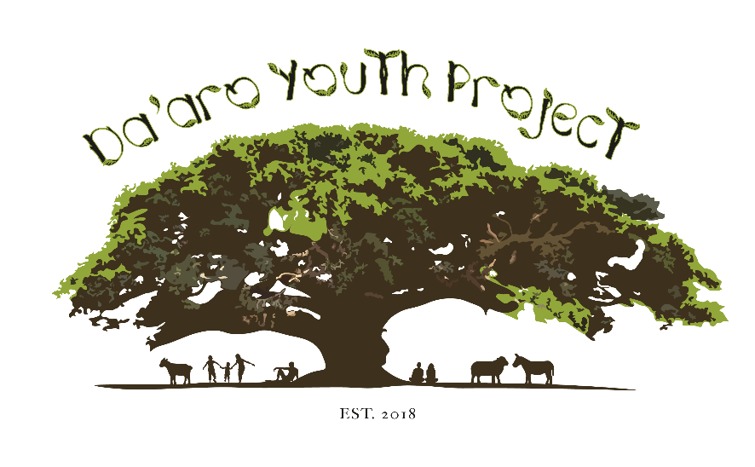

***Job Description***

Job Title: Youth Caseworker

Responsible To: Casework Manager

Hours: Full time

Status: Permanent contract, pending the completion of a three month probation period

Salary: £30,000 per annum

Holiday Entitlement: 27 days per annum

Location: Hybrid

*\*Minimum two days per week at DYP’s main office in Streatham Hill and Knights Youth Centre, Streatham Hill. On occasion, we deliver outreach services in locations which are convenient for clients, this could be anywhere in London. Additional work from home.*

**Purpose of Role**

Da'aro Youth Project is looking for an experienced full-time caseworker to join our small team based in Streatham Hill, London.

This role involves working alongside young refugees, asylum seekers and other young migrants who are at risk or in crisis to ensure that they can access their statutory entitlements and progress in their personal, social and educational development so that they can thrive and achieve their full potential.

Our caseworkers offer holistic support, advice and practical assistance to young people aged 14 to 25 years. They work closely with statutory and voluntary organisations to ensure that the immediate and longer-term needs of our young people are adequately met. They encourage the active and meaningful participation of young people in all aspects of Da’aro Youth Project’s youth service delivery and support the staff team to ensure young people are well supported and safeguarded.

***About Da’aro Youth Project***

**We are a community-led organisation supporting young refugees from the Horn of Africa.**

Da'aro Youth Project was established in 2018 by members of the Eritrean community in London in response to the deaths of a number of teenage Eritreans by suicide. Eritreans were the largest nationality group of unaccompanied minors to arrive in the UK in 2017 and 2018. Asylum-seeking children and young adults arrive here after traumatic journeys through the Sahara Desert, Libya, the Mediterranean Sea and after crossing borders in Europe, such as in Calais. Once here, young people often struggle to adapt to new lives separated from their families, and find that navigating the complex asylum and social care systems can be stressful and traumatic.

We aim to promote the wellbeing of these migrant young people living in the UK, through direct support, through building bridges in the Eritrean community and through advocating for changes to unfair and discriminatory systems which undermine their wellbeing. We believe that building sustainable relationships of trust and support within the Eritrean community is the best way to empower young people and enable them to overcome their marginalisation within society.

**We want newly arrived asylum-seeking young people to feel at home and to know they have someone to turn to in a crisis.**

Towards this aim, we currently run a weekly youth club called ‘Injera Club’, which is a fun and lively space where young Eritrean, Ethiopian, Somali and Sudanese children and young people (and their friends) can relax, play games, socialise and eat homely food. From this space, we work with young people to identify if they have support needs and respond to these accordingly, through our trauma-informed casework service. As part of the casework service we provide 1-to-1 support, including general advice, emotional support, referrals to legal support and advocacy. Integral to all this work is enabling young people to advocate for themselves to make changes.

***Job description***

1. To build positive, respectful and supportive relationships with young people which encourage their engagement with Da’aro Youth Project and other services that promote their growth and development.
2. To advocate on behalf of children and young people to enable them to access their full statutory rights and entitlements to education, social services support, housing, healthcare and legal representation. To always stand up for and stand by the child or young person and show a good understanding of the structural barriers they face within the asylum and care systems.
3. To conduct needs assessments with young people, supporting them to understand the factors affecting their respective situations, and to work with them to develop agreed upon support plans that address any immediate and long-term barriers to progress.
4. To provide holistic, high quality casework support and advocacy to young people in need by:

* Accompanying young people to appointments with social services, solicitors, court hearings, GPs, mental health services, colleges/schools and other support services/ organisations where appropriate.
* Attending one of our weekly Youth Clubs (Tuesday or Thursday evenings) to offer casework/advice.
* Building effective partnerships with community organisations, local authorities and other stakeholders.
* Building and maintaining knowledge and expertise regarding the lived experiences of our client group by keeping abreast of policy, legislation and other relevant developments and attending events, partnership meetings and trainings where relevant to our work.

1. To ensure the active and meaningful participation of young people in all of DYP’s youth provision, ensuring that their voice is central to all service development and delivery.
2. To effectively update casework files and keep accurate written records of casework support provided using our casework database and case management system.
3. To support DYP management and colleagues by providing information and reports as required.
4. To maintain confidentiality when working with young people, save where a serious safeguarding concern may require a breach of confidentiality.
5. To build and maintain clear, professional boundaries with young people.
6. To maintain compliance with all DYP policies and procedures, especially those related to child and vulnerable adult protection.
7. To attend supervision sessions and appraisals with the Casework Manager.
8. To contribute to team meetings and collaborate positively with the DYP team.
9. To take initiative in pursuing and undertaking relevant trainings and display a commitment to developing further skills and maintaining accurate, up to date knowledge of the UK public sector and asylum system. To maintain an in depth understanding of the issues and policies affecting young people whether they are new arrivals, or refugees who have been in the UK for several years.
10. To abide by health and safety guidelines and support the team to ensure your own safety and that of colleagues.
11. To undertake other work as relevant and appropriate to the post as may be assigned by the Casework Manager.
12. To abide by the values, aims and principles of Da’aro Youth Project.

***Person specification***

The ideal candidate will have a minimum of two years’ experience as a caseworker. They must bring energy and determination to the role and must be committed to working in collaboration with young people who may be at high risk or in crisis. The ideal candidate will possess a proven ability to manage a complex caseload and the desire to work as a member of a small team to protect and promote the interests of some of the most vulnerable young people in our society. The ideal candidate will be committed to the achievement of long-term goals and will be passionate about ensuring that young people who have sought safety in the UK can access this and feel seen, heard and supported.

The ideal candidate will have previous experience in carrying out casework with children, young adults, and asylum seekers or migrants. In addition, spoken and written skills in one or more of the following languages are highly desirable: ***Amharic, Arabic, and/or Tigrinya.***

| **Experience** | **Essential** | **Desirable** |
| --- | --- | --- |
| Two years’ proven experience of working with young asylum-seekers or refugees. | √ |  |
| Experience working within a multi-agency framework. | √ |  |
| Substantial experience of delivering casework, advice and advocacy support to vulnerable young people; including recording and reporting planned work and output in line with organisational policy. | √ |  |
| Experience of working with or supervising volunteers. |  | √ |
| Lived experience of the asylum and immigration system in the UK. |  | √ |
| **Knowledge and understanding** |  |  |
| Degree, diploma or equivalent in community work, youth work, advice giving (NVQ level 3 or equivalent), social work or other relevant associated profession. |  | √ |
| In depth awareness of the issues and challenges faced by young people who are new arrivals, asylum-seekers, or refugees. | √ |  |
| Knowledge of the policies and legislation affecting young people who have recently arrived in the UK and asylum-seekers and refugees attempting to rebuild their lives here. | √ |  |
| Knowledge surrounding the current policies and objectives of the UK’s asylum and immigration system and how unaccompanied asylum-seeking children and young people are affected by these. In addition to a commitment to learning more about this as part of the role. | √ |  |
| Some grasp of the UK’s social care system, in addition to a commitment to learning more about this as part of the role. | √ |  |
| Ability to maintain confidentiality and uphold data protection requirements in line with relevant legislation. | √ |  |
| Proficiency surrounding child protection procedures and equivalent in relation to safeguarding vulnerable adults up to the age of 25. | √ |  |
| **Skills and Abilities** |  |  |
| Tigrinya, Amharic or Arabic language skills. |  | √ |
| Ability to listen and work with discretion and sensitivity in a non-judgemental manner, demonstrating a kind, consistent and empathetic approach to working with young people. | √ |  |
| Ability to provide effective holistic support whilst maintaining healthy boundaries with young people. | √ |  |
| IT skills, including competence using Microsoft Office and databases such as CRM Salesforce. | √ |  |
| Excellent written and verbal communication skills (English). | √ |  |
| Effective time management skills including the ability to prioritise and manage complex and competing tasks efficiently. | √ |  |
| Proactive and willing to take initiative. | √ |  |
| Proven ability to work as part of a small team and be flexible and willing to work collaboratively. | √ |  |