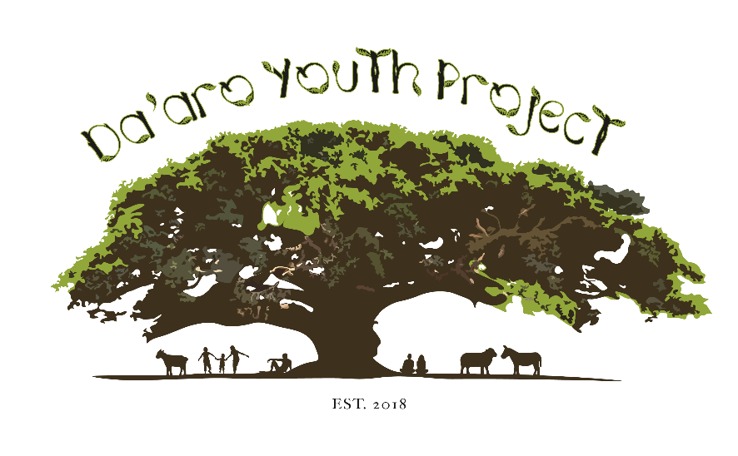

**Freelance Mentoring and Activities Assistant**

**Term**

This Agreement will commence upon the first agreed working date and will be renewed monthly under the discretion of the joint management team at DYP.

**Job Title**

Freelance Mentoring and Activities Assistant

* Assisting the DYP Youth Activities Lead and Youth Mentoring Lead with tasks and administrative duties delegated by both leads and Youth Service Manager.

This could include but is not limited to:

* Data entry and reporting
* Collecting and processing documentation for clients
* Undertaking relevant trainings to support with administrative and interactive roles
* Joint research to supplement mentoring and activities
* Creating social media content for the organisation and activities
* Oversight of provisions required for youth clubs, trips and activities
* Attend regular meetings with the Mentoring and activities leads

**Hours of work**

This consultancy role has part time hours of 3 days (21 hours) per week.

**Fee**

You will be paid a fee of £135.00 per day. This daily fee will be payable by bank transfer monthly upon DYP’s receipt from the Casework of an invoice that describes the Work that the Casework has provided (Duties as above) to DYP and the dates when this work has been carried out.

**Location**

The administrative base for your employment will be DYP, The Woodlawns Centre, 16 Leigham Court Road, SW16 2PJ . However, you will be required to work from home and in other locations, for example our Injera Club if necessary for the work and in consultation with your supervisor.

**Expenses**

The Mentoring and Activities Assistant shall only be entitled to reimbursement of reasonable expenses that are actually incurred and allocable solely to the work provided to DYP in carrying out the responsibilities above. The Mentoring and Activities Assistant shall have prior authorisation from the manager and provide reasonable evidence of costs and will claim these using DYP’s staff expenses form.

**Termination**.

Either party may terminate this Agreement with 2 weeks prior written notice to the other party. The Mentoring and Activities Assistant hereby acknowledges and agrees that in the event of such termination, DYP shall only be liable for, and the Mentoring and Activities Assistant agrees only to retain, payment of the portion of the consultancy fee earned as a result of work actually and satisfactorily performed up to and including the effective date of termination.

**No Employment Relationship Created**.

It is understood and agreed between the parties that this agreement is not intended to nor does it constitute an employment contract between DYP and the Mentoring and Activities Assistant and any of their employees. Nor does it create a joint relationship or partnership between the parties. The Mentoring and Activities Assistant is not entitled to benefits that DYP provides for DYP employees. The Mentoring and Activities Assistant’s relationship to DYP is solely and exclusively that of an independent contractor. Neither party shall use the name or logo of the other party or incur any obligation or expense for or on behalf of the other party without the other party’s prior written consent in each instance.

**PAYE and National Insurance**

The Mentoring and Activities Assistant is solely and exclusively responsible for the satisfaction of their own income tax and National Insurance that may be applicable to the amounts payable by DYP under this agreement.

**Compliance with DYP Policies and procedures**

The Mentoring and Activities Assistant shall comply with all DYP policies and procedures with respect to the Youth activities under or in connection with this Agreement, including, but not limited to Confidentiality Policy, Data Protection Policy, Equity, Diversity and Inclusion Policy, Safeguarding Policy, Health and Safety Policy.

**Amendments**

This Agreement may be amended or modified only by a writing countersigned by authorized representatives of each party.